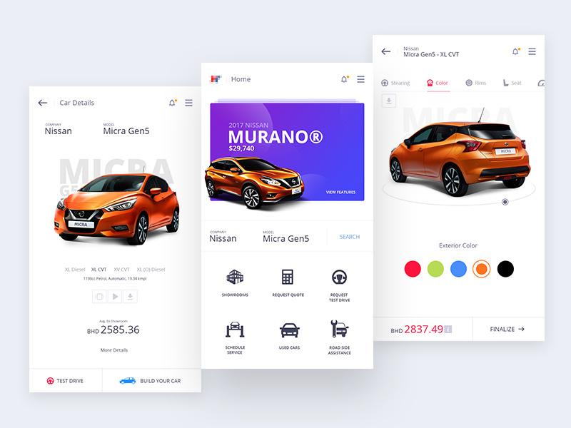

Nissan

It’s attractive and simple.

Easy to use, you can request a quote

You can check the used cars

You can also choose the color of the car you want

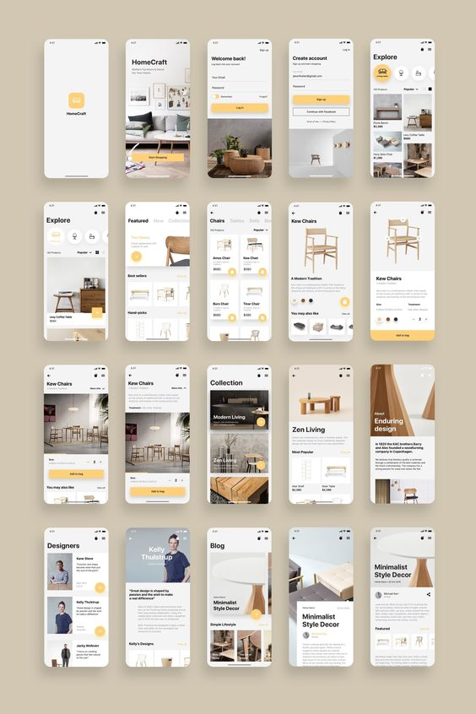

* The pictures looks similar
* Same format
* Same content

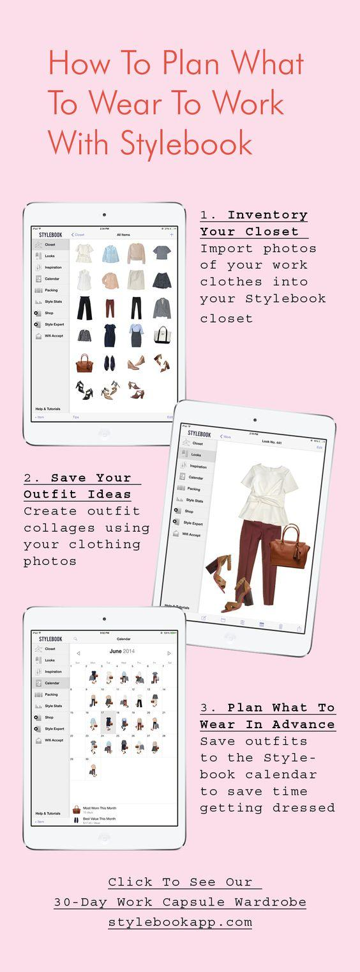

* It helps you see how you match the outfit
* Simple and easy to understand
* You can also go through there links to check